**Term 2 - 2024**

**BIOLOGY**

**FORM 4**

**PAPER 2**

NAME._______________________________________ ADMNO.___________

STREAM____________________ NAME OF SCHOOL____________________

DATE________________________________ SIGN________________________

**FORM FOUR EXAMINATIONS**

BIOLOGY THEORY

231/2

TIME: 2HRS

**INSTRUCTIONS**

1. This paper has **TWO** sections: **A** and **B**
2. **All** Questions in Section **A** are **Compulsory**
3. Question **6** is Compulsory
4. Choose Either Question 7 **or** 8
5. Write your Answers in the Spaces Provided
6. Wrong Spelling of Technical Terms shall be **Penalized**

|  |  |  |  |
| --- | --- | --- | --- |
| **Section** | **Question** | **Max Score** | **Student’s Score** |
| A | **1** | **8** |  |
| **2** | **8** |  |
| **3** | **8** |  |
| **4** | **8** |  |
| **5** | **8** |  |
| B | **6** | **20** |  |
| **7 or 8** | **20** |  |
| TOTAL SCORE | | **80** |  |

**SECTION A (40 MARKS)**

1. The following is a diagram representing stoma in terrestrial plants. **Q** is the appearance when **P** was placed in the dark for 6 hours.

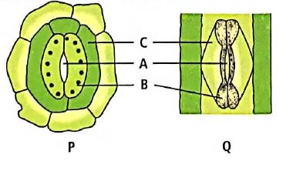

1. State the importance of closure of **A** being as seen in **Q** to the plant  (1mk)
2. State **TWO** modifications found in Cells **B** and not **C**  (2mks)
3. What is the importance of part **A** to photosynthesis? (1mk)
4. Account for appearance of **A** as seen in **Q** using the Potassium Ion theory (4mks)

1. The following is an illustration of an important feature of the nervous system

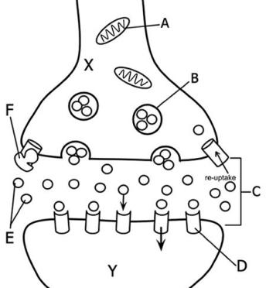

1. Name the chemical found in part labeled **B**  (1mk)
2. Give the importance of the structure above to the functioning of the nervous system

(1mk)

1. What is the significance of high number of organelle **A** in the region **X**? (2mks)
2. Describe how an impulse reaches region marked **Y** (4mks)

.

1. In a given species of beetles, a cross between red wing beetle and orange wing beetle produces F1 off-springs with yellow wings.
2. Explain the absence of red wing and orange wing in the F1 (2mks)
3. If the F1 were selfed, work out the genotypes of the offspring’s

(use capital R to represent the gene for red colour and capital O for the orange colour)

(4mks)

1. From the genetic cross in b) above give the following:
2. Genotypic ratio (1mk)
3. Phenotypic ratio (1mk)
4. Use the illustration of a cell shown below to answer questions that follow

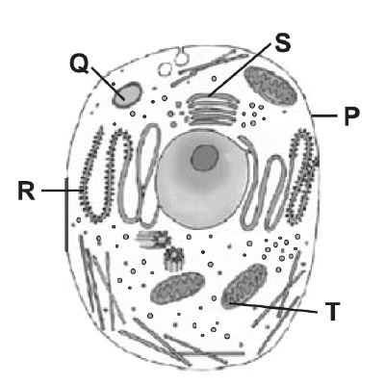

1. Give **TWO** reasons why the above is an animal cell.

(2mks)

1. i) State the identity of organelle **T**  (1mk)

ii) Identify the substance processed in organelle **R** (1mk)

1. Which letter represents organelle that will be abundant in the following? (2mks)
2. Muscle tissue
3. Secretory glands.
4. State the significance of the following properties to the functioning of **P**  (2mks)
5. Being Polarised .
6. Semi-permeability
7. The following diagram is an illustration of kidney nephron

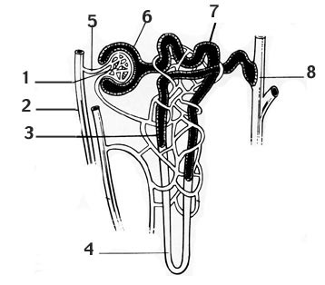

1. Identify the parts labeled:  (2mks)
2. **6**
3. **7**
4. State the importance of the following observations:
5. Vessel **2** being wider than vessel **5** (1mk)
6. Concentration of urea is higher in region **8** than in region **4**  (1mk)
7. Explain the importance of adrenal glands in region **4** when the blood has low ionic concentration  (2mks)
8. State the adaptations of region **7** in relation to mitochondria and microvilli

(2mks)

**SECTION B (40 MARKS)**

Answer **Question 6** which is **Compulsory;** then choose either Question **7** or **8**

1. The table shown below was developed after an experiment where raw potato strips were placed in different concentrations of sucrose.

|  |  |  |  |  |
| --- | --- | --- | --- | --- |
| **Concentration of sucrose solution (mol/dm3)** | **Initial length of potato strip (mm)** | **Final length of Potato strip (mm)** | **Change in length of potato strip (mm)** | **Percentage Change in length of Potato strip (%)** |
| **0.0** | 50.0 | 53.0 | 3.0 |  |
| **0.2** | 50.0 | 52.0 | 2.0 |  |
| **0.4** | 50.0 | 51.0 | 1.0 |  |
| **0.6** | 50.0 | 50.5 | 0.5 |  |
| **0.8** | 50.0 | 49.0 | -1.0 |  |
| **1.0** | 50.0 | 48.0 | -2.0 |  |
| **1.2** | 50.0 | 48.0 | -2.0 |  |

1. Complete the table above by filling in the column for percentage change in length of potato strip (%)  (3mks)
2. Account for the change in length of the potato strip at the following concentration of sucrose:
3. 0.2mol/dm3  (2mks)
4. 0.8mol/dm3  (2mks)

iii) 1.0 - 1.2 mol/dm3  (2mks)

1. On the graph below draw a graph of percentage change in length of the potato strip against concentration of sucrose.  (6mks)

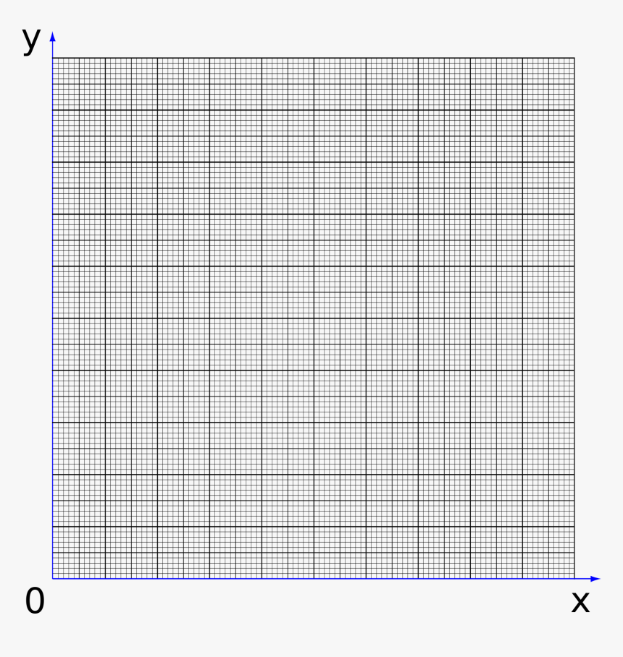

1. Determine the normal concentration of the potato cell sap from the graph. (1mk)

1. i) Explain how a potato strip placed at 1.4mol/dm3 can regain its normal shape.

(1mk)

ii) Name the process described in e (i) above  (1mk)

1. State **TWO** importance of Osmosis to animals.  (2mks)

1. a) During an ecological field study involving collection and observation of specimen, give **SIX** precautions that need to be observed.  (6mks)

b) Describe the effect of increased physical activity of an athlete on the following organs.

i) Skin  (7mks)

ii) Heart  (7mks)

1. a) Describe the process of exhalation in members of Class Mammalia.  (8mks)

b) Explain why drug abuse should be discouraged among youths.  (12mks)